Medford American
Little League
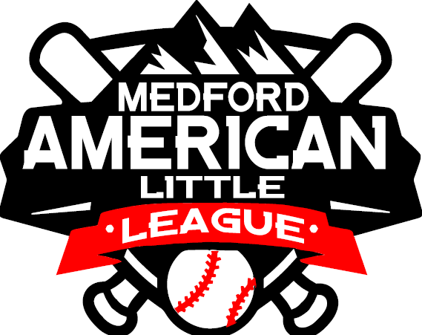

“Where Safety comes First”
2023 Safety Plan

League ID #: 4370609

Medford American Little League
Safety Program

Safety Mission Statement

Medford American Little League is a non-profit organization run by volunteers whose mission is to provide an opportunity for our community’s children to learn the game of baseball in a safe and friendly environment.

2023 Board of Directors

Title Name E-Mail or Phone___________
President Tyson Tobias 541-944-3189
Vice President Duane Patterson 619-933-0836
Secretary Nancy Patterson fundraiser@medfordamericanlittleleague.com
Treasurer Lorin Parsons registration@medfordamericanlittleleague.com
Safety Officer Nathan Sickler safety@medfordamericanlittleleague.com
Player Agent Audrey Saber softball@medfordamericanlittleleague.com
Umpire in Chief Duane Patterson umpire@medfordamericanlittleleague.com
Board Member Jesse Malanche mall@medfordamericanlittleleague.com

Distribution of Safety Manual
Each team will receive a paper copy of this safety manual. Managers and or Team Safety Officers should have a copy of the safety manual at all league functions.

EMERGENCY PHONE NUMBERS

Emergencies: Police, Fire and Medical 911
Non-Emergency Medford Police 541-770-4783
Text Emergency 911
Poison Control Center: 1-800-222-1222

Be Prepared to Tell: Location, Street Address, City
Directions
Telephone number from where the call is being made
Your Name
What happened (be brief but answer questions)
Your assessment of the condition of any injured party
Be able to tell what is being done for the injured party

DO NOT HANG UP UNTIL INSTRUCTED TO DO SO OR UNTIL AFTER THE DISPATCHER HANGS UP

NEIGHBORING HOSPITALS & URGENT CARE

NAME: Asante Rogue Regional Medical Center
ADDRESS: 2825 E Barnett Rd, Medford, OR
PHONE NUMBER: (541) 789-7000

NAME: Providence Medford Medical Center
ADDRESS: 1111 Crater Lake Ave, Medford, OR
PHONE NUMBER: (541) 732-5000

NAME: Valley Immediate Care
ADDRESS: 235 E Barnett Rd, Medford, OR
PHONE NUMBER: (541) 773-4029

NAME: Asante Urgent Care
ADDRESS: 555 Black Oak Dr, Medford, OR
PHONE NUMBER: (541) 789-2273

NAME: Providence Stewart Meadows Urgent Care
ADDRESS: 70 Bower Dr, Medford, OR
PHONE NUMBER: (541) 732-3962

Background Checks

Little League International has established criteria for each chartered league’s performance of an investigation into the background of all individuals who volunteer in any capacity. Each volunteer will be required to complete a volunteer application form and provide a copy of their government issued photo identification. The minimum requirement for these background investigations is verification that volunteers are not registered sex offenders. To provide additional protection to the children we will submit a list of all volunteers to JDP. A background investigation that will list any convictions nationwide will be completed. Upon clearance of individual background investigations all volunteers will be notified by The Board of Directors.

Click here to review and fill out volunteer application

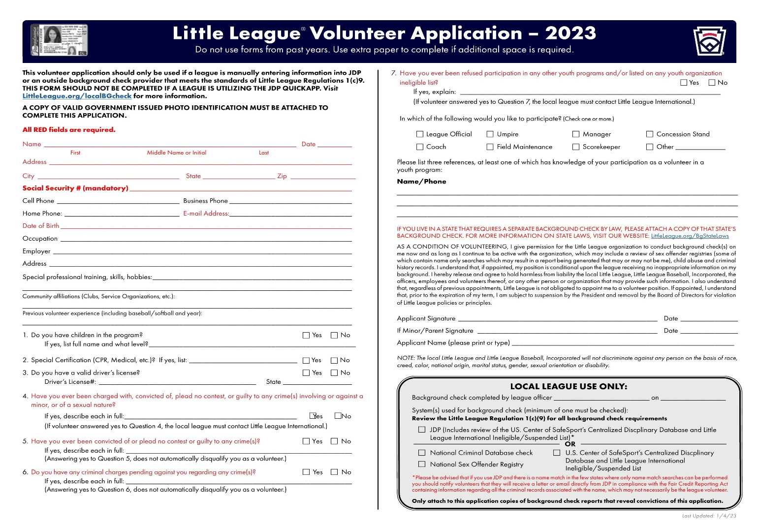

League Training Dates and Times

Date Location Time
Coach Fundamental Training: March 19, 2023 Field 6 9:00 am

Date Location Time
Safety Manual & First-Aid Training: March 19, 2023 Online 7:00 pm
Requirement 2: Each team will receive a paper copy of this safety manual. Managers and or Team Safety Officers should have a copy of the safety manual at all league functions.

Concussion Training: CDC online course will be required by all volunteers, especially coaches & managers. Other certifications will be accepted if accredited.

Field Inspections and Storage Procedures
BEFORE THE SEASON STARTS
- Familiarize yourself with the safety materials.
- Appoint a Safety Parent for your team. They need to be at all the games and have a cellular phone. It can be an Assistant Coach.
PRIOR TO EACH GAME and OR PRACTICE
- Complete a field safety checklist. Report any problems to your Field Representative or to the League Safety Officer.
- Check the team equipment for any problems. Report any equipment problems to the Field Representative.
- Check the contents in your team’s first aid kit. Contact the League Safety Officer or Field Representative for any items that need to be replaced.

STORAGE SHED
The following applies to the entire storage shed used by the League and applies to anyone who has been issued a code to use those sheds.

- All individuals are aware of their responsibility for the orderly and safe storage of rakes, shovels, and bases.
- Before you use any equipment located in the shed (lights, scoreboards, etc.) please read the written operating procedures for that equipment.
- All chemicals or organic materials stored in the sheds shall be properly marked and labeled as to its contents.
- Any witnessed “loose” chemicals or organic materials within these sheds should be cleaned up and disposed of as soon as possible to prevent accidental poisoning.

Annual Little League Facility Survey will be submitted in the Data Center.

PRE-GAME FIELD INSPECTION CHECK LIST
MANAGERS NAME:
FIELD:
DATE: Time:
Field Condition | Yes | No | Catchers Equipment | Yes | No
Backstop Intact |  |  | Hockey Catchers Helmet
Home Plate Intact |  |  | Dangling Throat Guard
Bases Secure |  |  | Helmets
Pitcher’s Mound Safe |  |  | Catcher’s Mitt
Batter Box Lined/Level |  |  | Chest Protector
Infield Fence Repair |  |  | Shin guards
Outfield Fence Repair |  |  | Dugouts | Yes | No
Foul Lines Marked |  |  | Fencing Needs Repair
Infield Need Repairs |  |  | Bench Needs Repair
Outfield Need Repairs |  |  | Trash Cans
Warning Track |  |  | Clean Up Is Needed
Coaches boxes Lined
Free Of Foreign Objects |  |  | Spectator Area | Yes | No
Grass Surface Even |  |  | Bleachers Need Repair
Area clear of needles |  |  | Protective Screens Ok
Player Equipment | Yes | No | Bleachers Clean
Batting Helmets |  |  | Parking Area Safe
Jewelry Removed |  |  | Safety Equipment | Yes | No
Shoes/Bats Inspected |  |  | First-aid Kit Each Team
Face Mask (Minor/Mjrs) |  |  | Medical Release Forms
Proper Cleats |  |  | Ice Pack/Ice
Athletic Cups (boys) |  |  | Safety Manual
Full Uniform |  |  | Injury Report Forms
Bats Meet Standards |  |  | Drinking Water
REPORT ANY PROBLEMS TO YOUR FIELD REPRESENTATIVE OR SAFETY OFFICER.
Equipment Inspection
- This Little League requires regular inspection of playing equipment.
- Unsafe equipment should not be given in team equipment bags.
- Managers, Coaches and Umpires are required to inspect equipment prior to each use.
- Bad equipment will be logged and will be removed and destroyed.

Accident Reporting Procedure

What to Report: An incident that causes a Payer, Manager, Coach or Umpire to receive medical treatment or first aid must be reported to The Safety Officer.

When to Report: All such incidents described above must be reported to The Safety Officer within 24 to 48 hours of the incident.

The Safety Officer is: NAME: Nathan Sickler
Email: safety@medfordamericanlittleleague.com

How to Make a Report: Reporting incidents can come in a variety of forms. Most typically they are telephone conversations. At a minimum, the following information is needed.
- The name and address of the injured person.
- The date, time, and location of the incident.
- As detailed of a description of the incident as possible.
- The preliminary estimation of the extent of the injury.
- The name and phone number of the person making the report.
- Names and phone number of any witnesses.

In your safety packet you will find the injury report forms. If your Safety Parent is there, he/she can assist you in getting the front of the form filled out. Then a call is to be made to The Safety Officer reporting the incident within 48 hours. Little League insurance is a supplemental insurance to the insured’s own insurance. There is a small deductible.

How to Replace the Injury Report Forms: The forms can be replaced by The Safety Officer or downloaded from www.littleleague.org found under forms and publications.

Submitting Player, Manager and Coach Data
Player, Manager, and Coach information will be submitted through the Little League Data Center at www.littleleague.org by May 7, 2023, or two weeks following the draft.
We will answer the survey questions in the Little League Data Center.

FIRST AID KITS
Each team is provided with a league issued first aid kit. Each kit includes the following.
(5) Adhesive sterile bandage
(3 Extra-large adhesive sterile bandage
(2) Non-adherent pads 2 x 3
(2) Gauze pad 12-ply 3 x 3 sterile
(1) Elastic tape
(1) Instant cold compress 4 x 4
(3) Triple antibiotic ointment
(5) Antiseptic towelette
(2) Pairs gloves
(1) CPR mask

Additional/replacement supplies are available in the equipment shed and full first aid kit is in the concession stand.

Communicable Disease Procedures
(Appropriate Personal Protection Equipment should be worn prior to rendering aid if possible)

- Bleeding must be stopped, the open wound covered, and the uniform changed if there is blood on it before the athlete may continue.
- Routinely use gloves to prevent mucous membrane exposure when contact with blood or other body fluids is anticipated (Provided in the first aid kit).
- Immediately wash hands and other skin surfaces if contaminated with blood.
- Clean all blood contaminated surfaces and equipment using a 10/1 bleach solution or equivalent.
- Managers, Coaches, and Volunteers with open wounds should refrain from all direct contact until the condition is resolved.
- Follow accepted guidelines in the immediate control of bleeding and disposal when handling bloody dressings, mouth guards and other articles containing body fluids.

Automated External Defibrillator (A.E.D)

The A.E.D. is in the equipment shed, prominently displayed for identification and retrieval. The A.E.D. should be retrieved/used if an individual is experiencing a potential medical issue and is unconscious and/or sudden cardiac arrest is suspected. There is no formal training required to use the A.E.D., however if someone who is trained in the use of the A.E.D. and/or C.P.R. they should take initial control over the suspected medical emergency until relieved by medical personnel.
If the A.E.D. is use, please notify the safety officer or other board member immediately so the A.E.D. can be cleaned, pads replaced, and returned to ready status as soon as possible. Please review the video attached (clicking on the links below) to familiarize yourself how to use the A.E.D.

https://www.youtube.com/watch?v=UFvL7wTFzl0

https://www.youtube.com/watch?v=7ukk5hOV8e0

Enforcement of Little League Rules
All volunteers must have a volunteer application filled out and on file with the Little League. Our league will provide annual background checks.
- No laminated bat shall be used… (rule 1.10)
- The traditional batting donut is not permissible… (rule 1.10)
- A pitcher shall not wear any items on his/her hands, wrists or arms which may be distraction to the batter. White long sleeve shirts are not permitted… (rule 1.11)
- Pitcher shall not wear sweat bands on his/her wrists… (rule 1.15)
- Players must not wear jewelry… (rule 1.11)
- Catcher must wear a catcher’s mitt… (rule 1.12)
- All batters must wear protective batting helmets, all helmets must bear the NOCAE stamp, No painting, or stickers on helmets… (rule 1.16)
- All male players must wear athletic supporters. Male catchers must wear the metal, fiber, or plastic type protective cup.
- Catcher’s helmet must have the dangling type throat protector and catcher’s helmet must be worn during infield/outfield practice, pitcher warm-up and games.
- Skull caps are not permitted… (rule 1.17)
- Each team is allowed three coaches in the dugout…
- Mangers or coaches may not warm up a pitcher at home plate or in the bull pen or elsewhere at any time… (rule 3.09)
- Coaches are encouraged to discourage “horseplay”
- No on deck batters are allowed in the Majors and below… (rule 1.08)
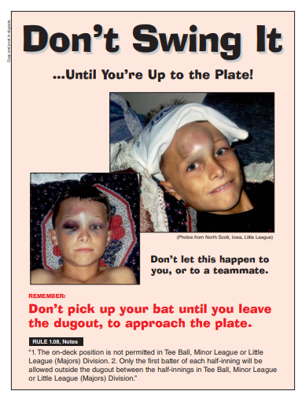
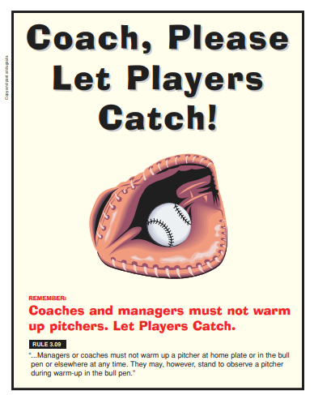

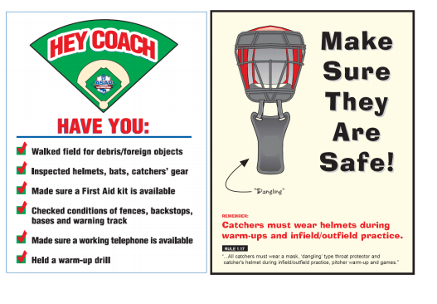

Lightning Facts and Procedures

Consider the following facts:

- The average lightning strike is 6-8 miles long.
- The average thunderstorm is 6-10 miles wide and travels about 25 miles an hour.
- On the average, thunder can only be heard over 3-4 miles, depending on humidity, terrain, and other factors. This means that by the time you hear the thunder, you are already in the risk area for lightning strikes.

Rule of Thumb: The ultimate truth about lightning is that it is unpredictable and cannot be prevented. Therefore, a manager or coach who feels threatened should contact the head umpire and recommend stopping play and clearing the field. In our league the umpire makes the decision as to whether play is stopped. Once play is stopped, take the kids to safety until play resumes or game is called.

Where to Go? No place is safe from lightning threat, but some places are safer than others. Constructed buildings are usually the safest. Most people will find shelter in a fully enclosed metal vehicle with the windows rolled up. If you are stranded in an open area, put your feet together, crouch down and put your hands over your ears to prevent eardrum damage.

Where not to go? Avoid high places and open fields, isolated trees, unprotected gazebos, rain or picnic shelters, dugouts, flagpoles, light poles, bleachers, metal fences and water.

First Aid for a Lightning Victim:
- Call 911 immediately.
- Typically, the lightning victim has similar symptoms as that of someone having a heart attack. Consider: will moving cause anymore injury. If the victim is in a high-risk area, determine if movement is necessary. Lightning does strike twice in the same place. If you are not at risk, and moving is a viable option, you should move the victim.
- If the victim is not breathing, start mouth to mouth resuscitation. If it is decided to move the victim, give a few quick breaths prior to moving the victim.
- Determine if the victim has a pulse. If no pulse is detected, start cardiac compressions as well.

NOTE: CPR should only be administered by a person knowledgeable and trained in the technique.
Remember: Safety is everyone’s job. Prevention is the key to reducing accidents to a minimum. Report all hazardous conditions to the Safety Officer or another Board Member immediately. Do not play on an unsafe field or with unsafe equipment. Check the teams’ equipment prior to each use.
Hydration
All Managers, Coaches and Players are required to being their own water bottle or sports drinks. Due to Covid no sharing of water bottles or sports drinks.
Tips to Prevent Heat Illness:
- Know that once you are thirsty you are already dehydrated.
- Drink before you become thirsty.
- Drink plenty of liquids like water, or sports drinks every 15 minutes.
- Water seems to be the preferred beverage. Water has many critical functions in the body that are important for performance they include, carrying oxygen and nutrients to exercising muscles.
- Do not drink beverages with caffeine before practice or games. Caffeine can increase the rate of dehydration.
- Do not exercise vigorously during the hottest time of the day.
- Practice in the morning and during the latter part of the evening.
- Wear light color loose cloths.
- Use sunscreen to prevent sunburn.
- If you begin to feel faint or dizzy stop your activity and cool off by sitting in the shade, air-conditioned car or use a wet rag to cool you off.

How is it treated?
Emergency medical treatment is necessary. If you think someone has heatstroke, call 911 or a doctor immediately. In the meantime, give first aid as follows:
- Move the person to a shady area.
- Cover the person with a wet sheet and keep the sheet wet for cooling from evaporation.
- Fan the person with paper or an electric fan (preferably not cold air).
- Sponge down the body, especially the head, with cool water.
- Continue giving first aid until the body feels cool to the touch.
- If the person is conscious, let them sip water, fruit juice, or a soft drink.
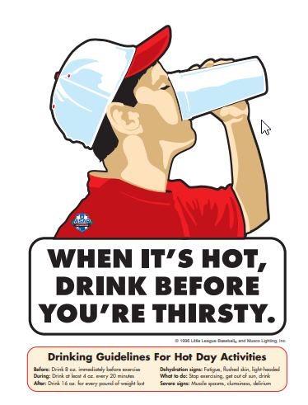

Concussions

Oregon Revised Statute §417.875 defines “league governing body” as an association of non-school athletic teams that provide instruction and training for team members and may compete with one another and who are affiliated, sponsored or organized by a non-profit organization established as provided by Oregon Law and defines “non-school athletic team” as an athletic team having members who are under eighteen (18) years of age and not affiliated with an Oregon public school. The law requires that each league adopt policies establishing training requirements and procedures and that coaches shall receive annual training recognizing and obtaining proper treatment for individuals suspected of sustaining a concussion. A coach may not permit a non-school team member to return to play on the same day, if concussion symptoms are present subsequent to an observed or suspected blow to the head or if diagnosed with a concussion until the member no longer exhibits signs, symptoms or behaviors consistent with a concussion and after receiving a medical release from a qualified health care professional.

Section 417.875 also provides that a coach may allow a non-school athletic team member to return to play at any time after a determination by a licensed athletic trainer or physician licensed under Oregon Law that team member did not sustain a concussion. The league governing body is required to develop guidelines and other material to facilitate informing non-school athletic team members, parents and coaches about signs and symptoms of a concussion. Each year prior to participation, a parent of an individual under 12 years and a parent and the individual if twelve (12) years of age or older must acknowledge receipt of the concussion information and materials. A league governing body may hold an informal meeting prior to the commencement of the season. Any person regularly serving as a coach or umpire who complies with the statute is immune from liability absent gross negligence or willful or wanton misconduct.

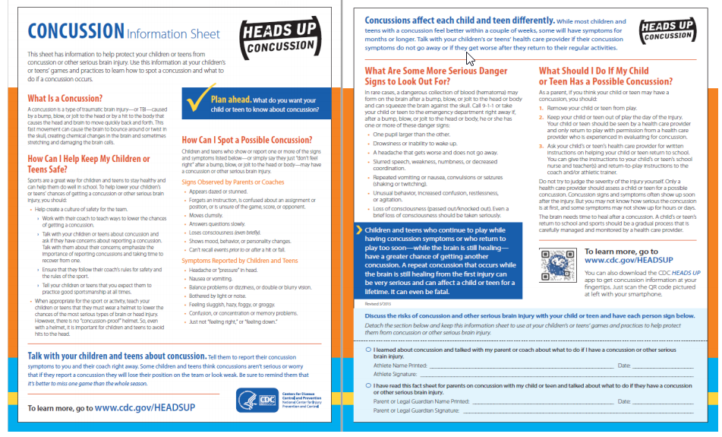

Medford American Little League Concussion Prevention, Treatment and Management Policy

The Legislature enacted a law which requires youth sports organizations to adopt a policy concerning the prevention and treatment of injuries to the head which may occur during a youth’s participation in competitive sports, including, without limitation, a concussion of the brain.
A concussion is a brain injury that results from a bump, blow or jolt to the head or body which causes the brain to move rapidly in the skull and which disrupts normal brain function. The Centers for Disease Control and Prevention of the United States Department of Health and Human Services estimates that as many as 3.8 million concussions occur each year in the United States which are related to participation in sports and other recreational activities. Athletes who continue to participate in an athletic activity while suffering from a concussion or suffering from the symptoms of an injury to the head are at greater risk for catastrophic injury to the brain or even death. Ensuring that a Little League player who sustains or is suspected of sustaining a concussion or other injury to the head receives appropriate medical care before returning to baseball activity will significantly reduce the child’s risk of sustaining greater injury in the future.
THEREFORE, Medford American Little League hereby adopts the following policy for purposes of prevention, treatment, and management of injuries to the head that may occur during a player’s participation in the Little League program, including, without limitation, a concussion of the brain:
1. Prior to a team’s first practice each season, every manager, coach, and adult assistant shall:
a) Familiarize themselves with the CDC publication “Heads Up – Concussion in Youth Sports – A Fact Sheet for Coaches”. This publication will be provided to all such individuals by the League Safety Officer or other Board members; and,
b) Complete the CDC on-line training course at:
https://www.train.org/cdctrain/course/1089818/
A copy of the Certificate of Completion for each of the above individuals shall be submitted to the League Safety Officer.
2. If a Little League player sustains, or is suspected of sustaining, an injury to the head while participating in any Little League game or even the player must:
a. Be immediately removed from the game or event; and
b. May only return to Little League activity if the parent or legal guardian of the player provides a signed statement from a provider of health care indicating that the youth is medically cleared for Little League participation and the date on which the player may return to participation.
3. The Little League player and his or her parent or legal guardian must sign the statement below acknowledging that they have read and understand the terms and conditions of the policy and agree to be bound by the policy.

Medford American Little League Concussion Prevention, Management and Treatment Policy
Player and Parental Acknowledgement
We, the undersigned, acknowledge that we have been provided with a copy of the Medford American Little League Concussion Prevention, Management and Treatment Policy, and that we have read and understand the policy, or it has been read to us and we understand the same. We hereby agree to follow all procedures set forth in said Policy at all times during which our son or daughter participates in Little League activities and events.
Dated: ___________________ _________________________
Player
Dated: ___________________ _________________________ _________________________
Parent/Legal Guardian Parent/Legal Guardian
LEAGUE USE: Division: ____________ Team: ____________

Safe Sport Act

- “Protecting Young Victims from Sexual Abuse and SafeSport Authorization Act of 2017” became federal law in 2018
- The goal of SafeSport is to protect children from abusive situations by engaging more people in the reporting and education processes
- A volunteer now can be held legally responsible if they have firsthand knowledge and fail to report any type of Child Abuse to the correct parties
- SafeSport covers all types of Child Abuse both physical and psychological
- SafeSport prompted USA Baseball to create Pure Baseball

USA Baseball Pure Baseball Initiative

- Little League International and all local little league programs must adhere to the following requirements from the SafeSport Act:
- Reporting of Abuse involving a minor to the proper authorities
- All volunteers of a local league are now mandated reporters and could face criminal charges if the league chooses to ignore, or not report to the proper authorities, any witnessed act of child abuse, including sexual abuse, within 24 hours.
- Local leagues must be aware of the proper procedures to report any type of abuse in their state. Please reference www.LittleLeague.org/ChildAbuse
- Leagues must adopt a policy that prohibits retaliation for “good faith” reports of child abuse.
- Leagues must adopt a policy that limits one-one-one contact with minors.
- Leagues are highly encouraged to complete the Abuse Awareness training provided by USA Baseball and/or SafeSport.

https://www.littleleague.org/player-safety/child-protection-program/safesport-resources-parents/

https://www.usabdevelops.com/ItemDetail?iProductCode=OCAAA&Category=ONLINE&WebsiteKey=f50aacb2-a59e-4e43-8f67-29f48a308a9e
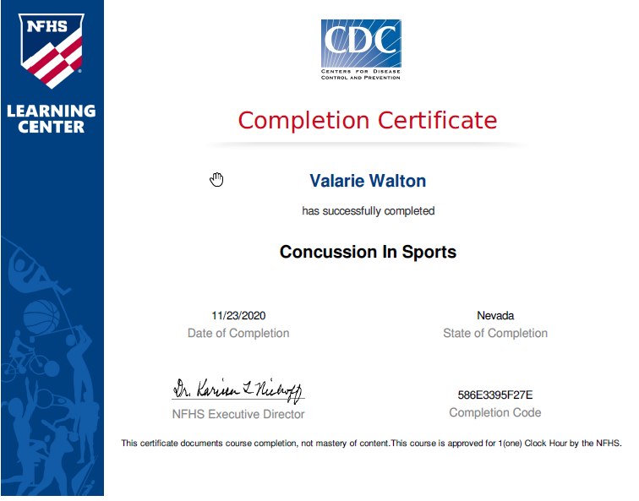
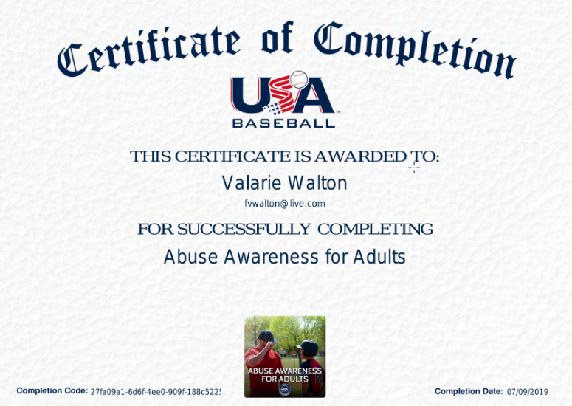

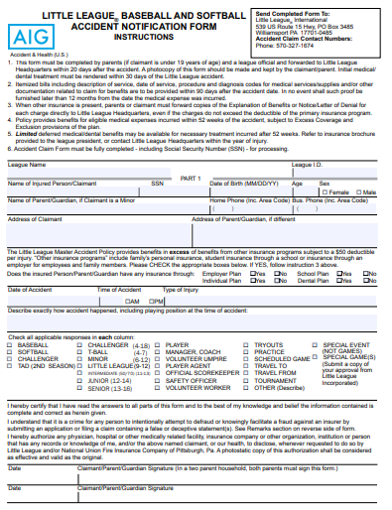
Accident Notification Form Page 1 (Parent/Guardian Statement)

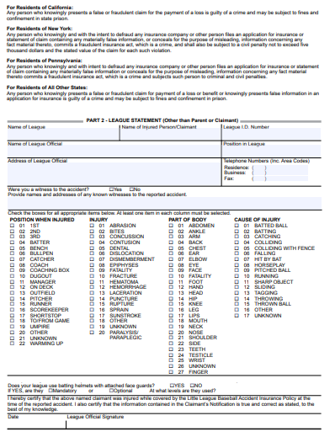
Accident Notification Form Page 2 (League Use Only)

